Chapter 19, Problem 36.

For the two-port in Fig. 19.94,

$\left[h\right]=\left[\begin{matrix}16Ω & 3 \\ -2 & 0.01S\end{matrix}\right]$

Find:
(a) V₂ / V₁
(b) I₂ / I₁
(c) I₁ / V₁
(d) V₂ / I₁

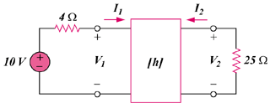

Figure 19.94
For Prob. 19.36.

